
Arab Academy for Science, Technology, and Maritime Transport
College of Engineering – Computer Engineering Dept.
Course | ECE3403 – Data Analytics & Optimization
Lecturer | Dr. Karma Fathalla – Dr. Doaa Shoieb
TAs | Yasmina Ayman – Hoda Osama – Marwan Nour

Sheet 3 - Exploratory Data Analysis

Question 1:
A survey was conducted among 50 individuals, asking them about their favorite streaming service. The responses were recorded as follows:
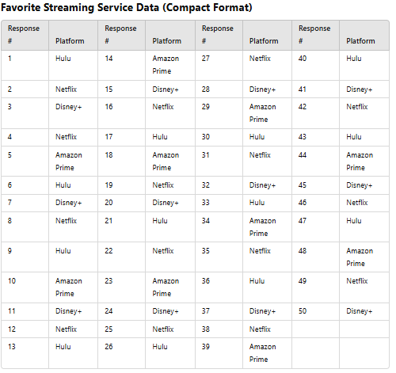
• What is the most preferred streaming service?
• What percentage of respondents chose Hulu?
• What is the total number of unique streaming services?

Question 2:
The table lists the total cash donations (rounded to millions of dollars) given by eight U.S. companies during the year 2010
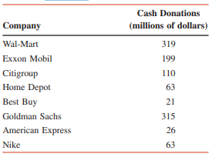
Cash Donations in 2010 by Eight U.S. Companies
Compute
- Measures of Central Tendency
- Measures of Dispersion
- Shape of Distribution

Question 3:
Given the plots:
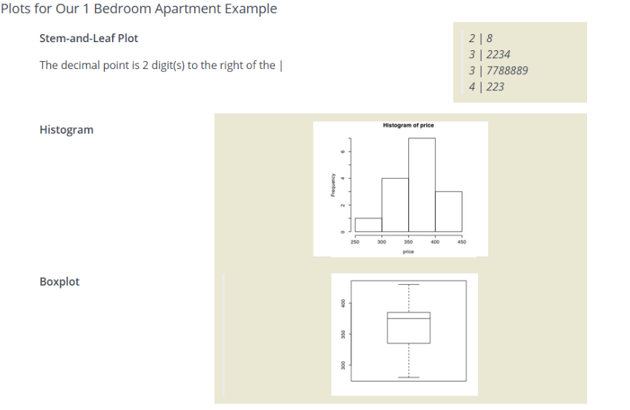
- What is the shape of the distribution?
- Any outliers?
- Is the median larger or smaller than the mean?

Question 4:
The following table represents data collected from six individuals on their daily water intake (liters), sleep duration (hours), physical activity (minutes per day), and BMI (Body Mass Index).
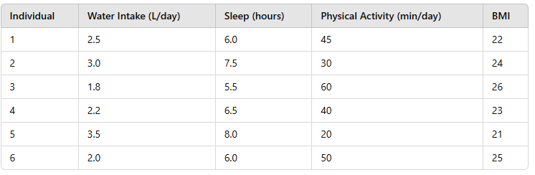

1. Compute the Correlation between Sleep and BMI.
2. Compute the Covariance between Water Intake and BMI

Question 5:
A researcher collected data on the number of hours students studied for an exam and their corresponding scores. The scatter plot below displays this data.
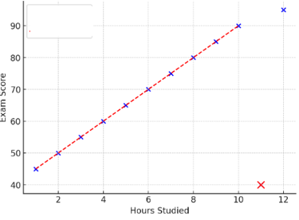
(a) Identify the pattern in the graph. Does it show a positive, negative, or no correlation?
(b) Based on the trend, estimate the expected score for a student who studied for 7 hours (interpolation).
(c) There is an outlier at (11, 40). How does this outlier affect the relationship between study hours and exam scores?
(d) What type of trend does the red dashed line represent?

